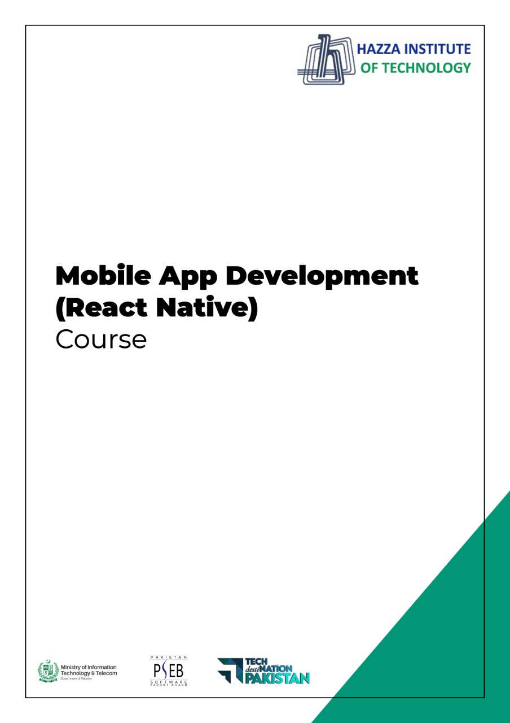

**(Flutter)**

Flutter Lab 3 (Session 2)

**Total Time:**

**6 hours (2 sessions)**

**Pre-Lab Activities:**

* + Basics of Flutter
  + Familiar with Android Studio and Flutter Application Mode
  + Familiar with Basic Widgets

**Learning Outcomes:**

* Demonstrate the knowledge of Flutter to design stateful, cross-platform, and interactive user interfaces for mobile applications.
* Demonstrate the basic widgets desgin

**Student Activities:**

* Student create a new flutter project in Android Studio and Write the code for some basic Widgets.

**Lab Tasks 1:**

1. Create a contact-card app that shows your contact details as given in following figure. The components and requirements of this app are given below.
   1. Include safe area
   2. Grey background
   3. Contain a circular avatar with an image, and 50 radius.
   4. Your name with following style guidelines
      1. A screenshot of a cell phone

         Description automatically generated with medium confidenceFont ZenKurenaido (custom Google font)
      2. Bold
      3. White Color
      4. Font size 30
   5. Your Designation with following style guidelines
      1. Font Lato (custom Google font)
      2. Bold
      3. White Color
      4. Font size 20
      5. Letter spacing 3
   6. Phone icon and contact number with green color, white background, padding, and margin
   7. Email icon and email with green color, white background, padding, and margin

**Lab Solutions:**

**LAB 3.1 : Practicing Layout Widgets.**

**CODE:**

|  |
| --- |
| import 'dart:ui';  import 'package:flutter/cupertino.dart';  import 'package:flutter/material.dart';  void main() {  runApp(const MyApp());  }  class MyApp extends StatelessWidget {  const MyApp({Key? key}) : super(key: key);  // This widget is the root of your application.  @override  Widget build(BuildContext context) {  return MaterialApp(  title: 'PortFolew',  home: Scaffold(  backgroundColor: Colors.teal,  body: SafeArea(  child: Column(  mainAxisAlignment: MainAxisAlignment.center,  children: [  CircleAvatar(  backgroundColor: Colors.amber,  radius: 70,  backgroundImage: AssetImage('images/myimage.jpg'),  ),  Text('Muhammad bin Abdul Ghaffar',style: TextStyle(  fontFamily: 'Schyler',  fontSize: 40,  fontWeight: FontWeight.bold,  color: Colors.white,  ),),  Text('Class Sixth', style: TextStyle(  color: Colors.amber,  fontSize: 20, letterSpacing: 2.5, fontWeight: FontWeight.bold),),  SizedBox(width: 150, height: 100,  child: Divider(color: Colors.white70),),  // Container with ListTile without rounded corner  Text('Container with List Tile without rounded corner'),  Container(  color: Colors.white,  margin: EdgeInsets.symmetric(vertical: 10, horizontal: 20),  child: ListTile(  title: Text('03314741950', style: TextStyle(color: Colors.teal, fontWeight: FontWeight.bold, fontSize: 18,), ),  leading: Icon(Icons.phone, color: Colors.teal,),  ),  ),  // card with ListTile with round corner  Text('Card with List Tile with round corner'),  Card(  color: Colors.white,  margin: EdgeInsets.symmetric(vertical: 10, horizontal: 20),  child: ListTile(  title: Text('abc@google.com', style: TextStyle(color: Colors.teal, fontWeight: FontWeight.bold, fontSize: 18),),  leading: Icon(Icons.email, color: Colors.teal,),  )),  // Container with Row  Text('Container with Row'),  Container(  padding: EdgeInsets.all(10),  color: Colors.white,  margin: EdgeInsets.symmetric(vertical: 10, horizontal: 20),  child: Row(  mainAxisAlignment: MainAxisAlignment.center,  children: [  Icon(Icons.phone, color: Colors.teal,),  SizedBox(width: 30,),  Text('03314741950', style: TextStyle(color: Colors.teal, fontWeight: FontWeight.bold, fontSize: 18,), )  ],  ),  ),  // Card with Padding & Row  Text('Card with Padding & Row'),  Card(  margin: EdgeInsets.symmetric(vertical: 10, horizontal: 20),  color: Colors.white,  elevation: 15.0,  child: Padding(  padding: EdgeInsets.all(10),  child: Row(  mainAxisAlignment: MainAxisAlignment.center,  children: [  Icon(Icons.email, color: Colors.teal,),  SizedBox(width: 30,),  Text('abc@google.com', style: TextStyle(color: Colors.teal, fontWeight: FontWeight.bold, fontSize: 18),),  ],  ),  ),  ),  ],  ),  ),  )  );  }  } |